SOMETHING YOU NEED FOR BUILD PROJECT:

1. Install nodejs.
2. Install node package manager (npm).
3. Install yarn.
4. Install java.
5. Install VSCODE.
6. Install INTELLIJ IDE.

* ALL THE THINGS I JUST MENTIONED ON YOUTUBE HAVE THE EASIEST TO UNDERSTAND INSTALLATION INSTRUCTION, SO IF YOUR LAPTOP OR PC DOESN’T HAVE ANYTHING, JUST SEARCH WITH KEYWORD “HOW TO INSTALL ..... TO WINDOW/ MACBOOK”

I have write all statement below of file “ deployment.yaml “ you can see the code in there. The statement has “-s -f “ is statement for remove and remain for pulling container.

Correct statements pulling always have “ up -d”, it’s look like this:

“ docker-compose -f ./deployment.yaml up -d mysql8-container “

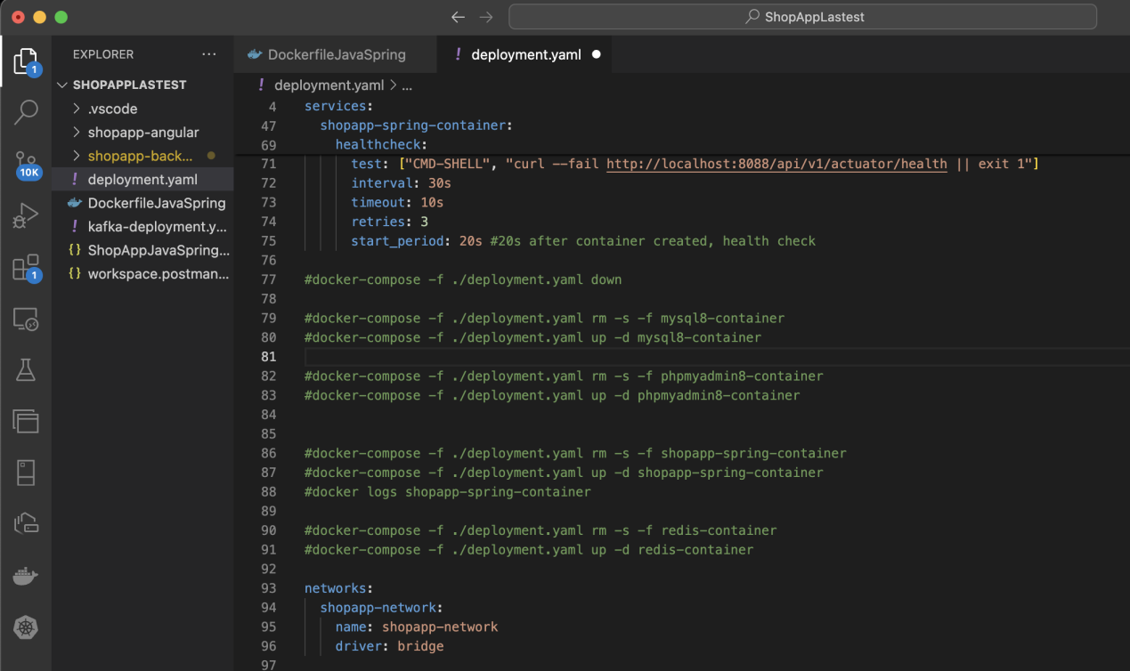

You can check all container by : “ docker ps “ for The container is running

and “ docker ps -a “ for all container you have.

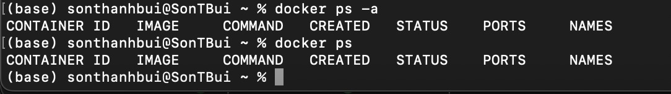

Below are step by step running my project.

Go to folder contain project

Check position: run:-> ls -la

If you have the same result like this, you are correct

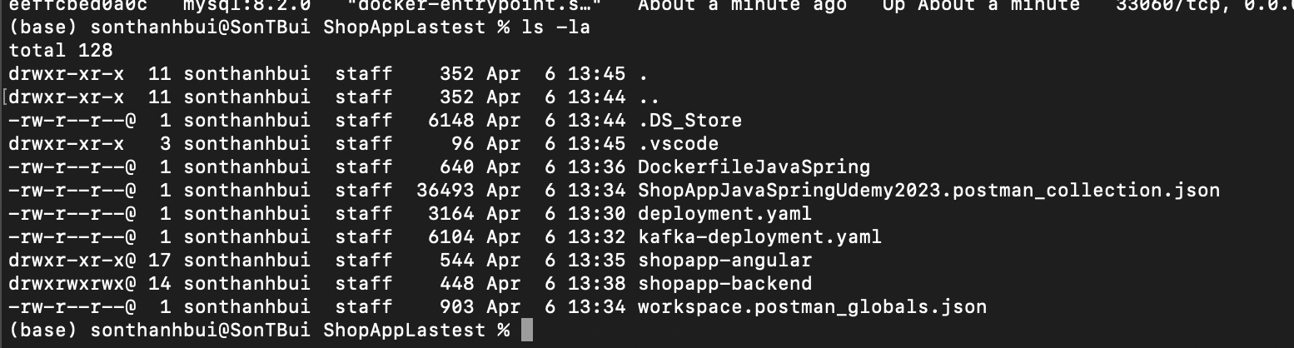

Run this statement: docker-compose -f ./deployment.yaml up -d mysql8-container

The result:

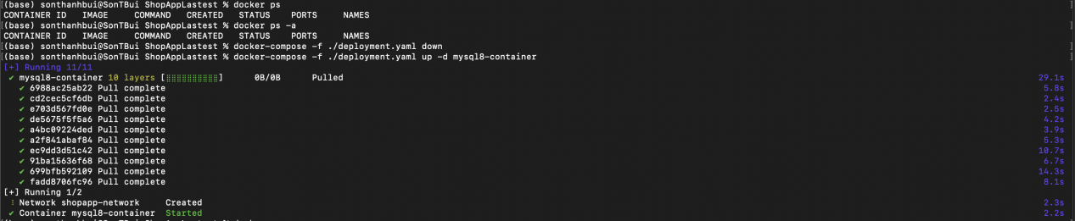

After that need check container was pulling in docker by: docker ps

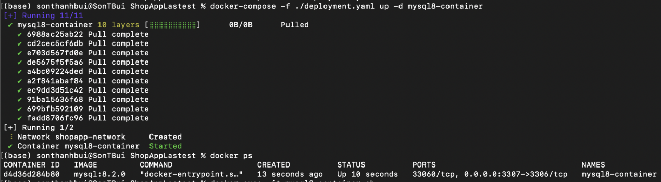

You need to check network after create container mysql8, statement: docker network ls.

The result like this:

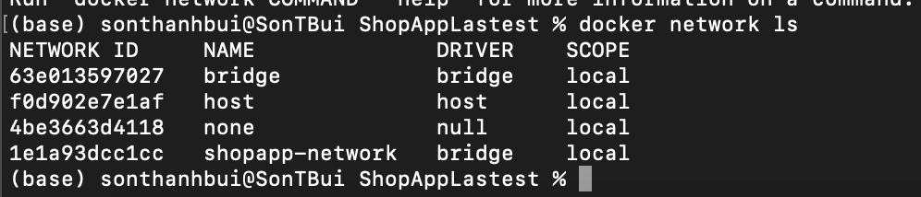

**\* Pulling container phpmyadmin.**

**Attention:** If you are using *window or mac intel,* you need to **NO** comment **line 21** in file deployment.yaml. And comment lines **23**. And if you are using mac m1 you need to **NO** comment **line 23**. And comments lines **21**.

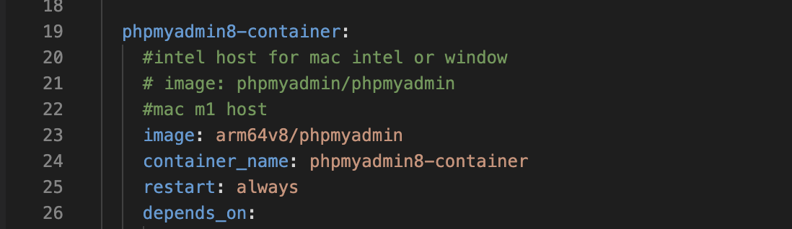

**For Mac M1**

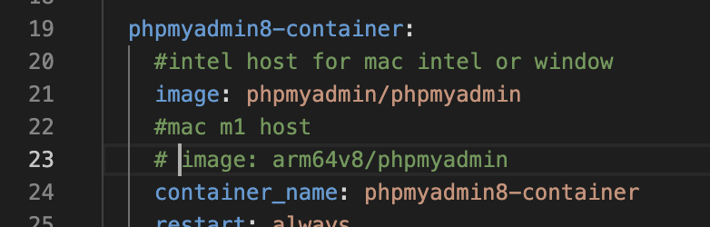

**For window or mac intel**

Next step is creating phpmyadmin8-container. **READ ATTENTION BEFORE RUN THIS STATEMENT.**

**Run this statement :**  docker-compose -f ./deployment.yaml up -d phpmyadmin8-container

Result same as create mysql8-container. My docker have phpmyadmin before, so my result like this:



**Then**, check image in your laptop or pc. statement is: “ **docker image ls** “ or

“ **docker images** ”

result here:

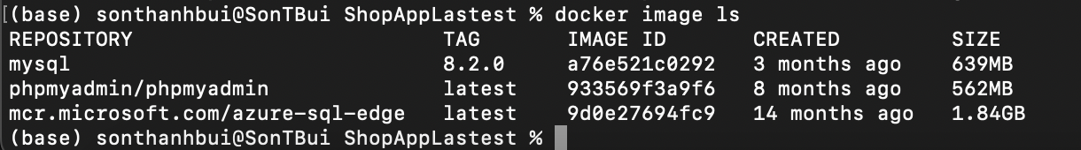

Next stage, open browser and find url: “ localhost:8100 ”(recommend using chrome for build project).

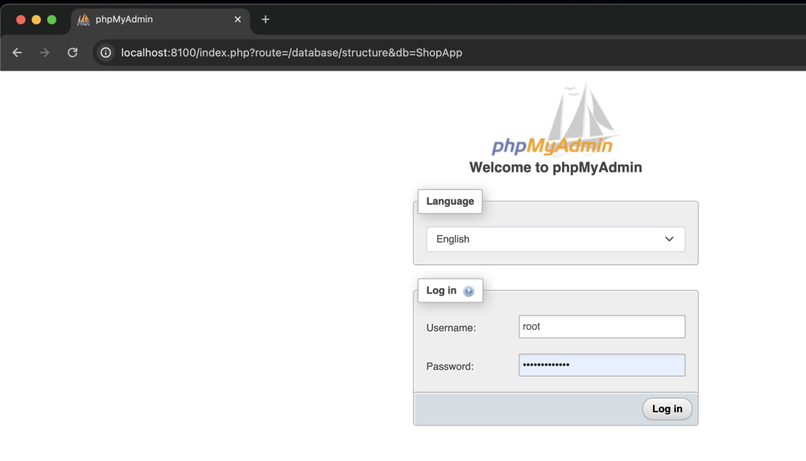

**username** is: root

**password** in deployment.yaml: Abc123456789@.

you can change the password before you create phpmyadmin and mysql8

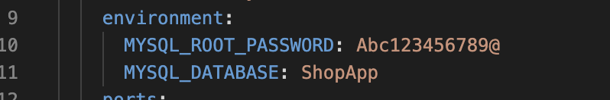

Next step you in import file database i was already build and put it on folder contain project.

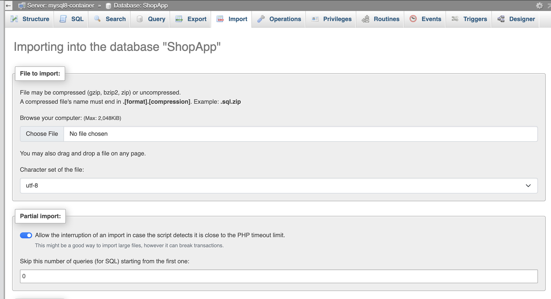

<-- Chose file shopapp.sql

Rolling down and press import.

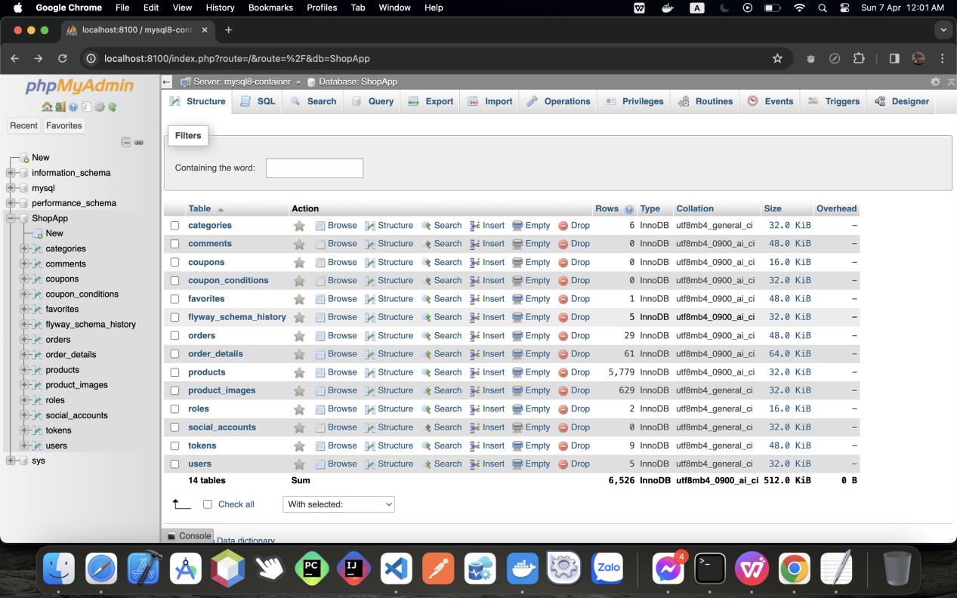

**You have successfully for project’s database.**

**Now we need connect backend to frontend. Follow instruction.**

***I have written statement below file deployment.yaml.***

**Run statements create redis**:

“docker-compose -f ./deployment.yaml up -d redis-container”

**Result:**

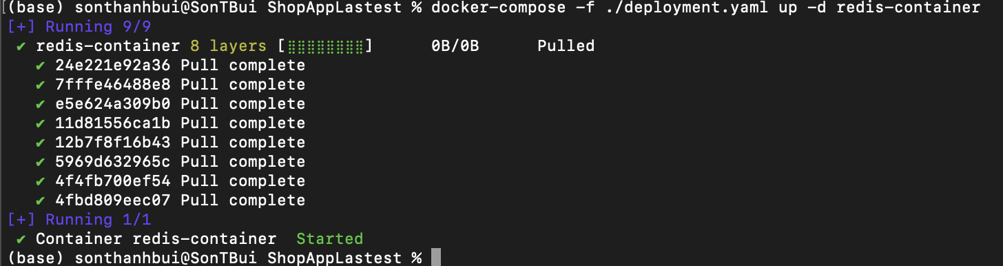

**Now go to file kafka-deployment.yaml to build zookeeper and kafka.**

**Run statement: create zookeeper-01**

“ docker-compose -f ./kafka-deployment.yaml up -d zookeeper-01 ”

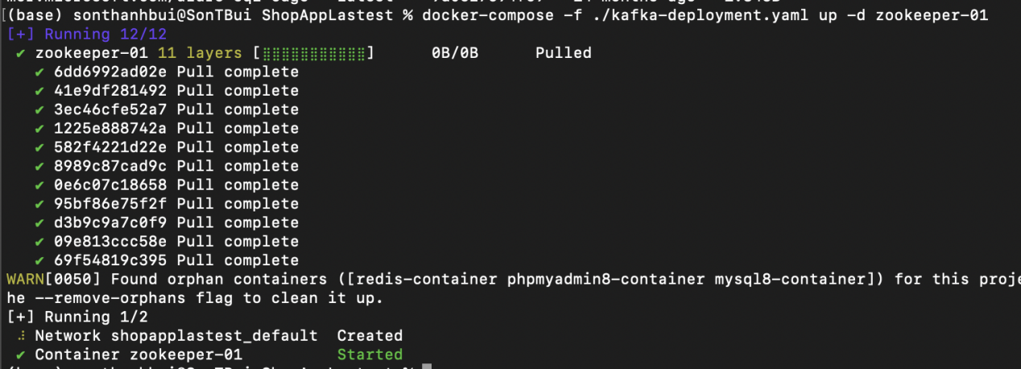

**Run statement: create zookeeper-02**

“ docker-compose -f ./kafka-deployment.yaml up -d zookeeper-02 ”

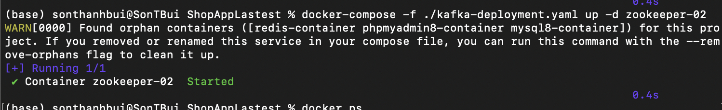

**Run statement: create zookeeper-03**

“ docker-compose -f ./kafka-deployment.yaml up -d zookeeper-03 ”

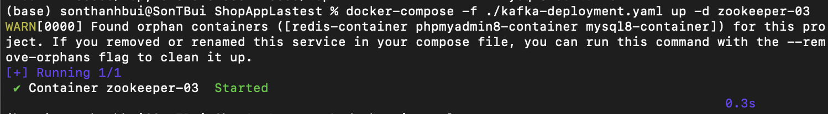

*DON’T WORRY ABOUT WHY CREATE ZOOKEEPER 02 AND 03 SO QUICKLY. BECAUSE THEY REUSE IMAGES*

If you run docker ps and you have results same as me, you are correct.

**\*Create kafka-broker-01.**

**Run statement:**

“ docker-compose -f ./kafka-deployment.yaml up -d kafka-broker-01 ”

The result:

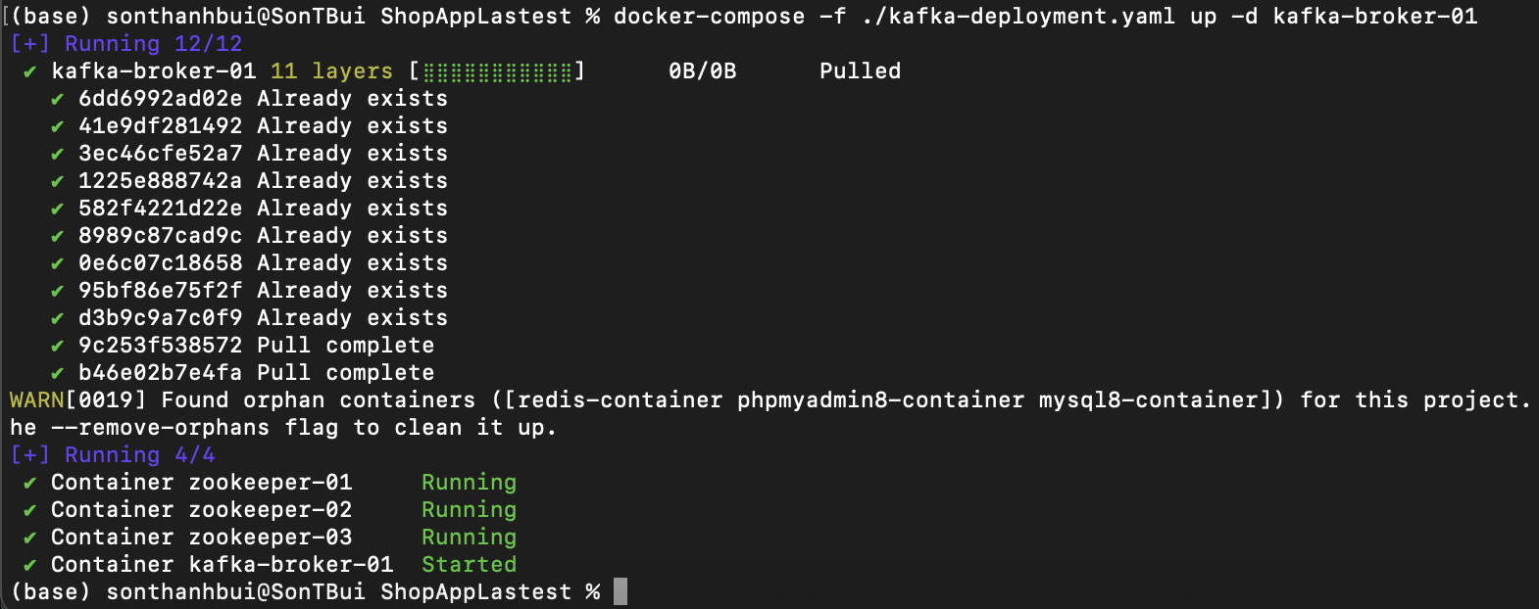

Next step, I prefer using IDE **INTELLIJ**. Open Folder “shopapp-backend”. And add plugin

**“LOMBOK”.** Then press apply - > ok.

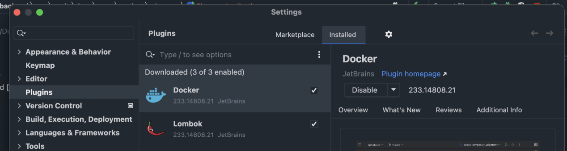

**Open Postman and import two file into postman.**

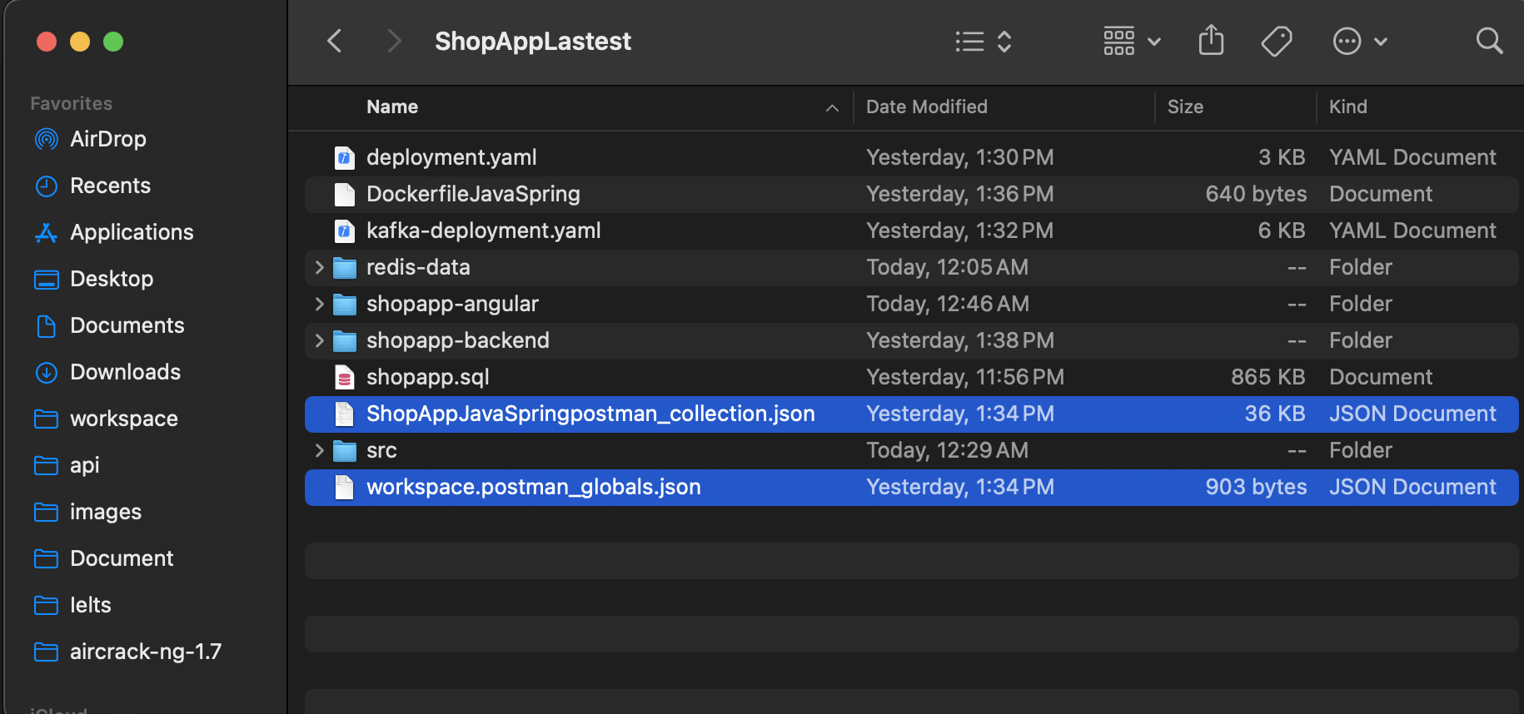

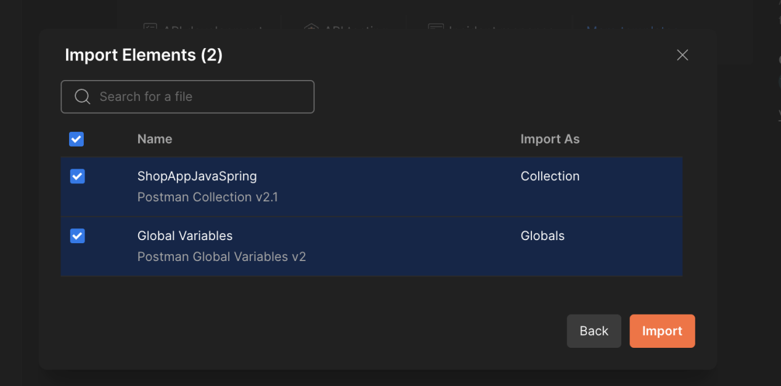

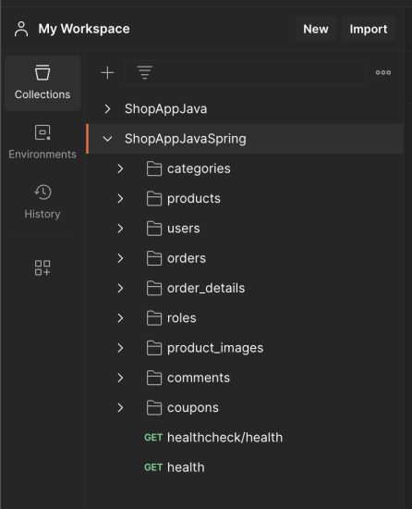 If you have screen same as picture you are done.

Open VSCODE. Open folder contain project. Use terminal in vscode to go to deep folder

shopapp-angular. And run code “ **yarn install** ”

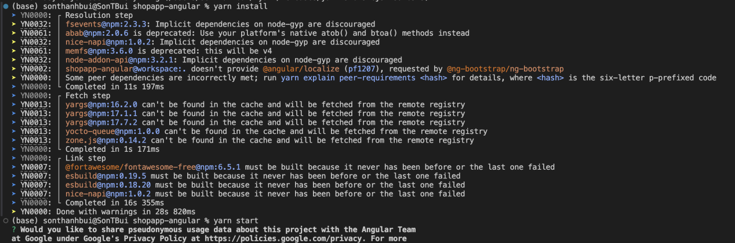

Press yes if you permission or no if you don’t want.

Then run “ **yarn start** ” to run this project.

